ARTIFICIAL INTELLIGENCE
Assignemnt 2
Jay Vankar
U24AI042
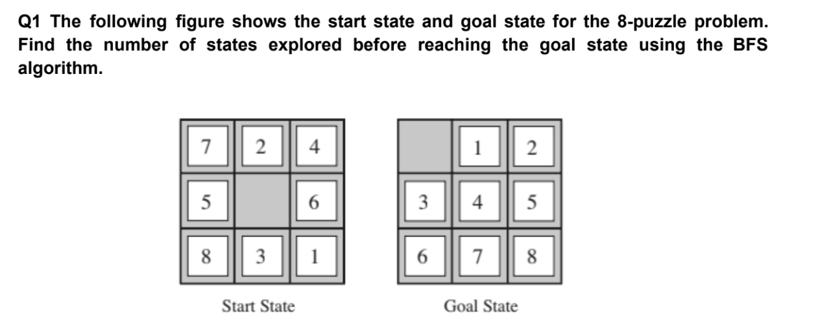
Code:

# Generate all possible next states
def generate_states(state):
states = []
zero_pos = state.index(0)

# Move UP
if zero_pos not in [0, 1, 2]:
new_state = state[:]
new_state[zero_pos], new_state[zero_pos - 3] = \
new_state[zero_pos - 3], new_state[zero_pos]
states.append(new_state)

# Move LEFT
if zero_pos not in [0, 3, 6]:
new_state = state[:]
new_state[zero_pos], new_state[zero_pos - 1] = \
new_state[zero_pos - 1], new_state[zero_pos]
states.append(new_state)

# Move DOWN
if zero_pos not in [6, 7, 8]:
new_state = state[:]
new_state[zero_pos], new_state[zero_pos + 3] = \
new_state[zero_pos + 3], new_state[zero_pos]
states.append(new_state)

# Move RIGHT
if zero_pos not in [2, 5, 8]:
new_state = state[:]
new_state[zero_pos], new_state[zero_pos + 1] = \
new_state[zero_pos + 1], new_state[zero_pos]
states.append(new_state)

return states

# BFS
def bfs(initial_state, goal_state):
open_list = [initial_state] #queue
visited = set([tuple(initial_state)])
states_explored = 0

while open_list:
current_state = open_list.pop(0)

if current_state == goal_state:
print("BFS Goal Found")
print("BFS States Explored:", states_explored)
return
states_explored += 1

for next_state in generate_states(current_state):
if tuple(next_state) not in visited:
visited.add(tuple(next_state))
open_list.append(next_state)

print("Goal not found using BFS")

#MAIN
initial_state = [7, 2, 4,
5, 0, 6,
8, 3, 1]

goal_state = [0, 1, 2,
3, 4, 5,
6, 7, 8]

bfs(initial_state, goal_state)
Output:
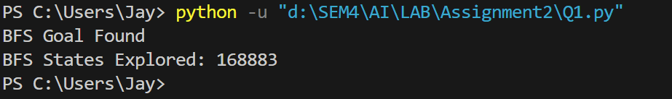

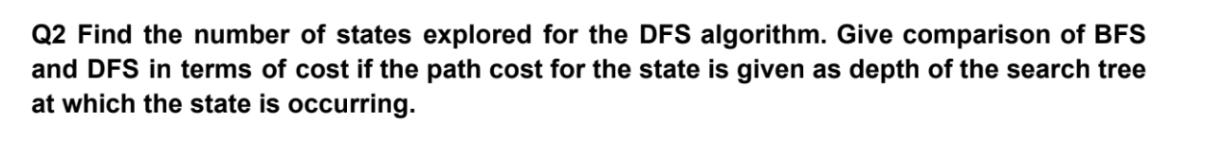
Code:
# Generate all possible next states
def generate_states(state):
states = []
zero_pos = state.index(0)

# Move UP
if zero_pos not in [0, 1, 2]:
new_state = state[:]
new_state[zero_pos], new_state[zero_pos - 3] = \
new_state[zero_pos - 3], new_state[zero_pos]
states.append(new_state)

# Move LEFT
if zero_pos not in [0, 3, 6]:
new_state = state[:]
new_state[zero_pos], new_state[zero_pos - 1] = \
new_state[zero_pos - 1], new_state[zero_pos]
states.append(new_state)

# Move DOWN
if zero_pos not in [6, 7, 8]:
new_state = state[:]
new_state[zero_pos], new_state[zero_pos + 3] = \
new_state[zero_pos + 3], new_state[zero_pos]
states.append(new_state)

# Move RIGHT
if zero_pos not in [2, 5, 8]:
new_state = state[:]
new_state[zero_pos], new_state[zero_pos + 1] = \
new_state[zero_pos + 1], new_state[zero_pos]
states.append(new_state)

return states

# DFS
def dfs(initial_state, goal_state):
stack = [initial_state]
visited = set([tuple(initial_state)])
states_explored = 0

while stack:
current_state = stack.pop()

if current_state == goal_state:
print("DFS Goal Found")
print("DFS States Explored:", states_explored)
return
states_explored += 1

for next_state in generate_states(current_state):
if tuple(next_state) not in visited:
visited.add(tuple(next_state))
stack.append(next_state)

print("Goal not found using DFS")

#MAIN
initial_state = [7, 2, 4,
5, 0, 6,
8, 3, 1]

goal_state = [0, 1, 2,
3, 4, 5,
6, 7, 8]

dfs(initial_state, goal_state)
Output:
